Volume 1 | Issue 1  31 January 2023 | 3/11 Foundation Newsletter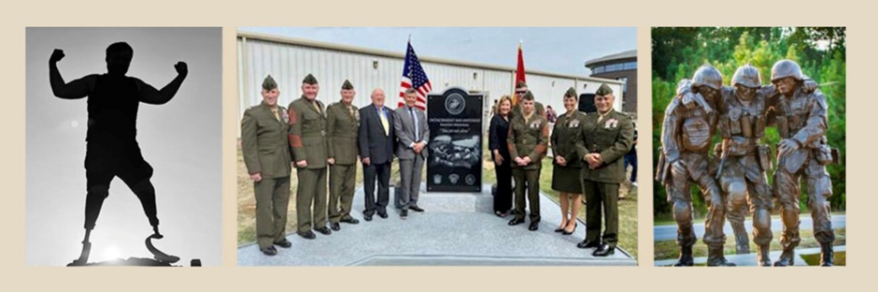 Incoming

The 3/11 Foundation is an Internal Revenue Service-recognized 501(c)(3) charity incorporated in the State of Texas with Federal tax ID 46-4240572.

Mission
The mission of the 3/11 Foundation is to aid wounded Marines; to continue to support the Marine Wounded Warrior Detachment at the San Antonio Military Medical Center; and to seek additional opportunities to help wounded Marines of every generation. Marine Wounded Warriors are defined as combat and non-combat wounded, ill, and injured Marines; Sailors attached to Marine units; and their family members.

President’s Message
The past year was a challenging one for all. We endured, however, and are moving into 2023 with a renewed enthusiasm to tackle the upcoming challenges. The Foundation will continue to support our wounded Marines and Sailors at SAMMC and those other Veterans in need. I am excited with our expansion into other areas. One such area of great concern is Veteran Suicide. The Foundation will continue to update the Association Members throughout the coming year. Included in this first Newsletter are only a few highlights of 2022. For all past accomplishments, please go to https://3-11marines.org/ . I would like to introduce the Foundation Board of Directors and Advisers:
Woodrow Hall President hwoodrow@charter.net
Nanci Visser Director / Secretary vissernan@aol.com
Sara Kliewer Director / Treasurer skliewer11@gmail.com
Charles Ables Director / Website Committee charleska@sbcglobal.net
Steve Battle Director / Finance Committee stephenbattle@comcast.net
Joni Madolora Director / Communications Committee jmango57@gmail.com
Barry Wortham, MD Director / Suicide Prevention Committee worba10@yahoo.com
Paul Jensen Board Adviser
Tom Pace Board Adviser
Eric Visser Board Adviser
Doug Miller Board Liaison with the 3/11 Association
Pat McConnaughay Web Master
Feel free to contact any Board Member with your concerns.

San Antonio Military Medical Center Memorial Dedication
Wounded Warrior Detachment, San Antonio
Memorial Dedication May 13, 2022

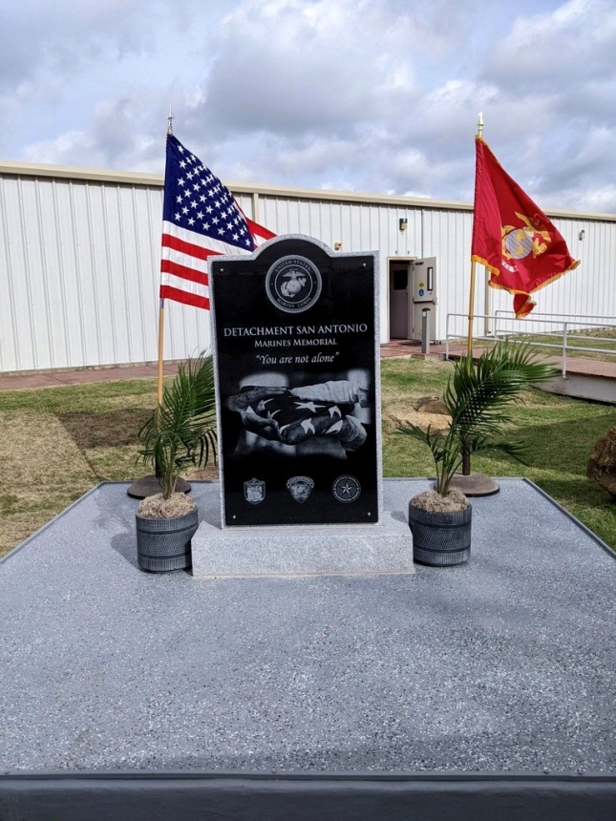
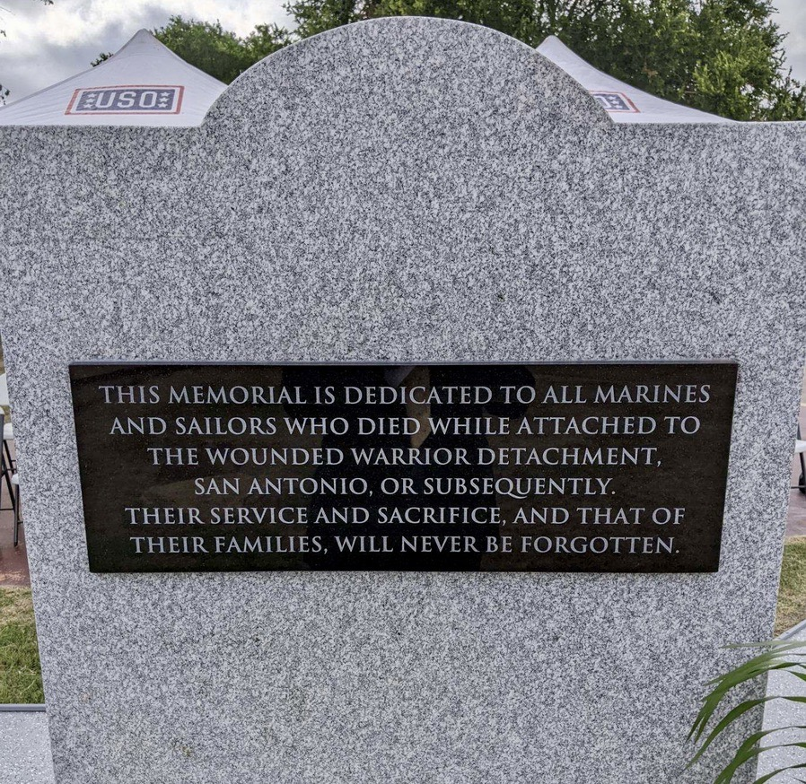
This permanent Memorial was made possible by generous donors and supporters of the 3/11 Foundation, to include many members of our 3/11 Association. It is dedicated to all Marines and Sailors who died while attached to the Wounded Warrior Detachment, San Antonio, or subsequently; the reverse side of the Memorial is so inscribed. Please go to the 3/11 Foundation website https://3-11marines.org for additional photos and greater detail on the Accomplishments page.

Suicide Prevention
The Suicide Prevention Committee was established to look for ways the 3/11 Foundation can help prevent suicide among Marine Wounded Warriors of every generation. The Board discussed how to mentor Wounded Marines who have passed through the Wounded Warrior Detachment, San Antonio. One idea was to ask for volunteers from the 3/11 Association and to assign Wounded Marines to them. The problem is how to reach out to the Wounded Marines to let them know these 3/11 mentors are available to them day or night. Dr. Barry Wortham has taken the lead on suicide prevention, and he and his committee have provided the Foundation and the Association Suicide Prevention Guidelines. Dr. Wortham gave an excellent presentation to the 3/11 Association membership at the Association’s Reunion in Kansas City, MO, on 23 September 2022 and emphasized the Suicide Prevention Guidelines. Please see photos and some of the guidelines below:
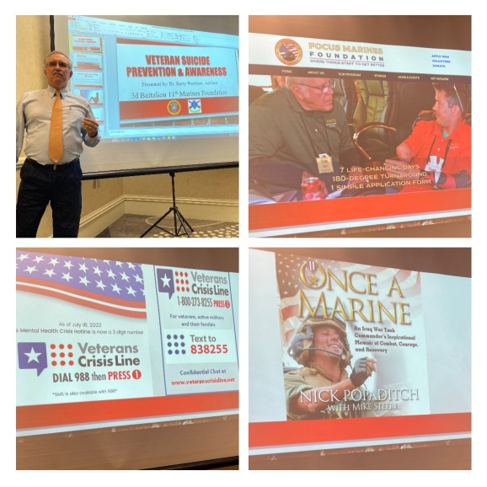
DO NOT COUNSEL THE PERSON YOURSELF; LEAD THEM TO SEEK PROFESSIONAL HELP:
- If you are struggling or know someone who is, hope is a reality, and help is available. CALL 1-800-273-8255 and PRESS 1 for toll-free, confidential help 24/7;
- DIAL 988 or go to the Veterans Crisis Website: https://www.veteranscrisisline.net/#Bethere#NSPW ;
- If you are a veteran or family member who is struggling, you are not alone. Go to Focus Marines Foundation at https://focusmarines.org ;
- “BE THE ONE TO STOP ONE” FROM COMMITTING SUICIDE. Find out how here: https://stopone.info/home .

Planet Aid Support
Thanks to Steve Battle, Planet Aid continues to send the 3/11 Foundation checks generated by clothing donations at three Massachusetts fire stations: Haverhill, Hudson, and Methuen.

Smile Amazon Support
Unfortunately, Amazon is discontinuing smile.amazon.com in February 2023. It is unfortunate because the 3/11 Foundation received .5% of every purchase, and it added up.

Candid (previously GuideStar USA, Inc.)
The Candid “transparency” requirements are still in place, and the Board will continue to comply with the reporting to have a Gold Seal (awarded in 2022 and in preceding years) or a Platinum Seal of Transparency. A Platinum Seal requires metrics that we don’t currently track but will discuss at the next Board Meeting in March 2023.

Thanksgiving
The Foundation provided Thanksgiving Dinner for the Marine Wounded Warriors and their families at the Wounded Warrior Detachment, San Antonio.

How to Donate
Please go to the Donate page of the 3/11 Foundation website to support our Wounded Warriors and their families: https://3-11marines.org/index.php/donate/ . You can donate by mailing a check to our Treasurer at 3/11 Foundation, 14126 Bluff Manor, San Antonio, TX 78216, or you can pay via PayPal at the link.
Since the 3/11 Foundation is a 501(c)(3) charity and fully qualified to receive Qualified Charitable Distributions (QCD’s), please consider making a charitable contribution to the 3/11 Foundation using the Required Minimum Distribution (RMD) from your Individual Retirement Arrangement (IRA). More information is at the link above. Thank you.
Look for signs  Empathize  Ask questions  Remove from danger  Next steps for more care    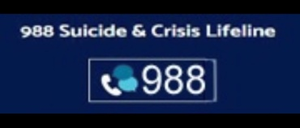   |   Chris Bryde

